**Aim:** Simulation or Implementation of FTP.

**Objective:** To develop programs on FTP and to promote sharing of files.

**Theory :**

File Transfer Protocol (FTP) is a standard communication protocol that allows users to transfer files between computers or through the cloud. FTP is built on a client-server model architecture that uses separate control and data connections between the client and the server.

FTP is used to:

* Download, upload, and transfer files
* Communicate and transfer files between computers on a TCP/IP network
* Transfer web page files from their creator to the computer that acts as a server for other computers on the internet

FTP works by:

* Opening two connections that link the computers trying to communicate with each other

Using separate control and data connections between the client and the server

* Users require an Internet connection in order to execute FTP transfers.

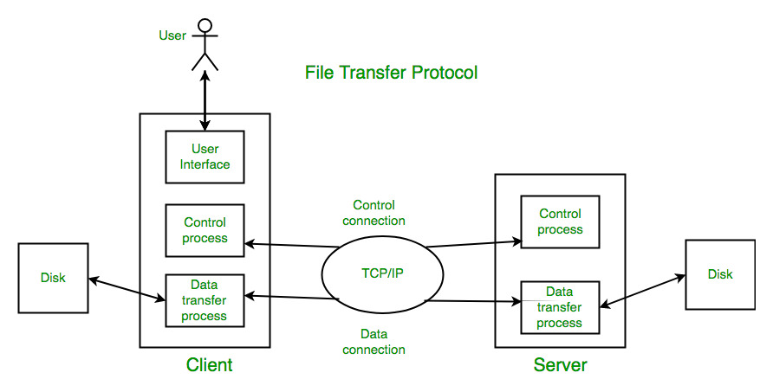

FTP typically defaults to using port 990. It uses a plaintext (unencrypted) sign-in process. FTP over explicit SSL/TLS (FTPES) is a commonly used approach by web and file sharing services to enable secure file transfers.FTP uses TCP at the transport layer. It uses port 21 for control connection and port 20 for data connection. FTP uses persistent TCP connections for control connection and non-persistent connections for data connection. They are primarily used for two essential functions, “Put” and “Get”. “Put” allows uploading files to the server from the client device and “Get” allows downloading files from the server on the client device.

**Conclusion:** To implement FTP application, where the Client on establishing a connection with the Server sends the name of the file it wishes to access remotely. The Server then sends the contents of the file to the Client, where it is stored.